Operations/Creatives, Content & Media
Assumptions:
- QUANTITY QUOTED TO BE ORDERED: 500-750
- Student from Lucknow University
VENDOR 1:
- Vendors Name
akashprints.com
USP – Economically feasible, closer if we want to travel and check the quality of the product.
- Number
- Email - contact@akashprints.com
- Location
Khazana Complex, FF-74, Kanpur Road, near PNB Bank
- Item And Price
- T-Shirt:
  - 2 prints available (1 logo size of 4 inch)Back print size 11x8inch
  - Colors Available : White / Yellow / Parrot Green / Orange / Sky Blue / PINK
  - Price of Round Neck – Quality (120 GSM) - Rs.120
  - Price Round Neck – Quality (160 GSM) - Rs.170

- Prices item with 2 prints on the POLO T-Shirt item:
  - COLORS - White, Orange, Yellow, Sky Blue, Camel Color, Parrot Green, Pink
  - Price of Collared – Quality (GSM 200) - Rs. 220

- Caps with Prints - Rs. 75

- Winter Hoodies

  - 2 prints (1 logo size of 4 inch)Back print size 11x8inch
  - Quality (350 GSM) – Rs 500
  - Colors Available – Black and white

- Quality
Quality of all the items has already been updated with the prices.
NOTE :
- Any extra print would charge Rs 30
- Prices are according to bulk order, further non-negotiable.

- Pictures for Reference:
  - Quality - GSM 120
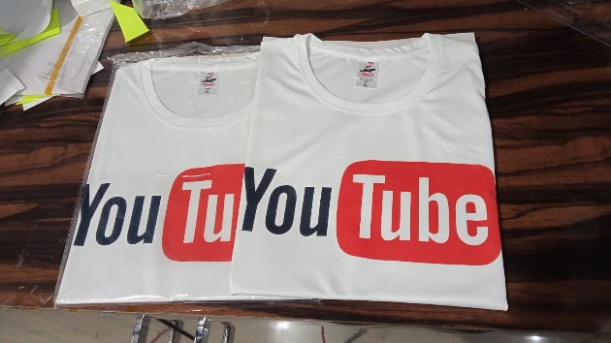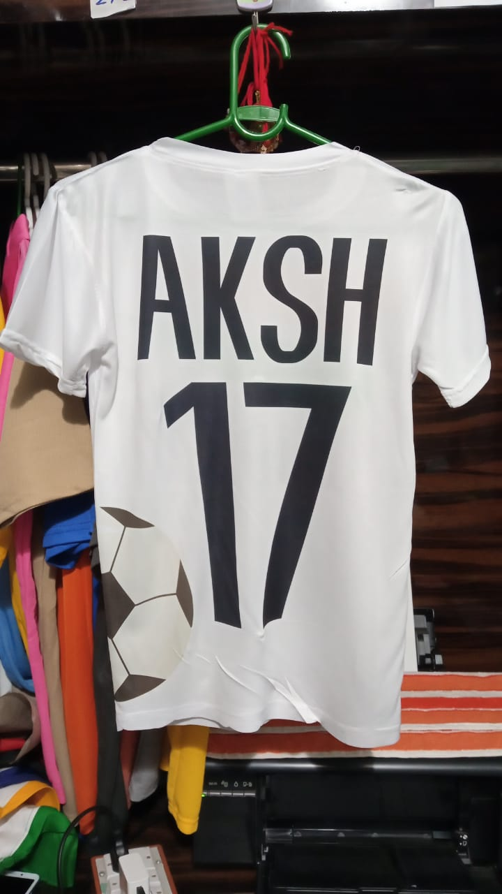

  - GSM POLO 220
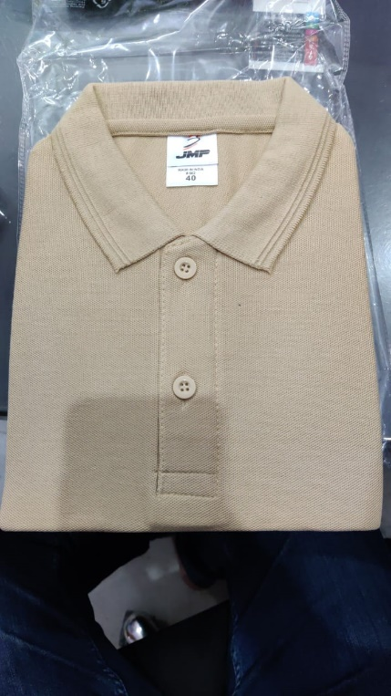

VENDOR 2:
- Vendor Name
www.vectormantra.com
USP - Has top quality material, has already been involved in making merchandises of IIM Bangalore, IIM Ahmedabad.
- Contact number - +91 78990 06603
- Email - www.vectormantra.com
- Location – Bangalore based Online merchandise
- Item and Price
- Hoodies
  - Premium quality 400 GSM
  - logo embroidered on the left chest
  - Extra features - bio washed, non zipper
  - Prices : INR 680 +GST@5% and shipment.
  - For INR 30 will be applicable per zipper.

- Caps
- Premium quality cotton caps can be manufactured
- Logo embroidered on the top.
- Prices - INR 170 +GST@5%

- T-Shirts
For Round neck Tshirts
  - Quality - 180 GSM
  - bio washed fabric
  - Prices - INR 290 +GST@5%
  - All general colors are available (colour print at front or at the back of the Tshirts)

Collared neck T shirts
- Quality - 280 GSM
- Prices - INR 490 +GST@5%
- logo embroidered on the left chest
- For back side print INR 30 per colour will be applicable
NOTE : Promotional Tshirts starts at INR 375 +GST@5% and shipment.

Samples to be found in the below link: https://www.vectormantra.com/custom-clothing-manufacturer-and-printing-services

VENDOR 3:
- Vendor Name
custprint.com
USP : This Vendor specializes in making Hoodies, T-shirts, Round Neck Shirts, Sports Tees, Varsity Jackets, Sweatshirts
- Contact Number - +91 88606 27006
- Location - 487/30, Peeraghari, Paschim Vihar, New Delhi, India-110087
- Item and Price
  - HOODIES
Zipper Hoodie
- Fabric: 100% Cotton Fleece
- GSM: 340
- Styling: Regular Fit
- Available in 8 colours
- Prices: Rs 575

Normal Hoodie
- Fabric: 100% Cotton Fleece
- GSM: 340
- Styling: Regular Fit
- Available in 8 colours
- Prices: Rs 525

  - Round Neck T-Shirts
- Fabric: 100% Cotton S/J
- Styling: Regular Fit
- Available in 6 colours
- Prices – Rs 149 (GSM - 160)
- Prices – 249 (GSM - 249)

  - Varsity Jackets
- Fabric: 100% Cotton Fleece
- GSM: 340
- Styling : Regular Fit
- Price: Rs 650

Prioritization matrix
3 different vendors have been chosen.
akashprints.com
vectormantra.com
custprint.com

Criteria | Economically | Geography | GSM (Quality Check) | # of Product Offered
1. | Akashprints | Akashprints | Vectormantra | Vectormantra
2. | Custprints | Custprints | Custprints | Custprints
3. | Vectormantra | Vectormantra | Akashprints | Akashprints

Conclusion:
From the above analysis, it seems like a good option to order all the textile merchandise (Hoodies, caps, varsity jacket, etc) from Custprints. It has variety of merch available, variety of colors, and has good selection of items.
From purely economical perspective – We can also go for Akashprints, but it would greatly lower the fest experience.

